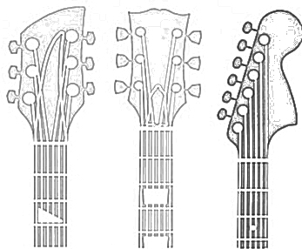
10 Minutes a Day!

Day | Monday | Tuesday | Wednesday | Thursday | Friday | Saturday | Sunday
Time

Done

Day | Monday | Tuesday | Wednesday | Thursday | Friday | Saturday | Sunday
Time

Done

Day | Monday | Tuesday | Wednesday | Thursday | Friday | Saturday | Sunday
Time

Done

Day | Monday | Tuesday | Wednesday | Thursday | Friday | Saturday | Sunday
Time

Done

